Commercialization of AMP Technologies through Improving the Stage-Gate Process

Prepared by:
Kenzy Lynn Pinney

Faculty Advisors:
Dr. Michael West
REU Site Director, Department of Materials and Metallurgical Engineering

Dr. Jennifer Karlin
Department of Industrial Engineering

Dr. Christian Widener
Director of AMP Center, Department of Materials and Metallurgical Engineering, Department of Mechanical Engineering

Dr. Alfred Boysen
Department of Humanities

Program Information:
National Science Foundation
Award #0852057

Research Experience of Undergraduates
Summer 2011

South Dakota School of Mines & Technology
501 East Saint Joseph Street
Rapid City, SD 57701

TABLE OF CONTENTS

Abstract……………………………………………………………………………………………………………………………………
Objectives……………………………………………………………………………………………………………………
Findings…………………………………………………………………………………………………………………………
Introduction…………………………………………………………………………………………………………………………………
Background………………………………………………………………………………………………………………………
Objectives……………………………………………………………………………………………………………………
Developmental Plan………………………………………………………………………………………………………
Broader Impact…………………………………………………………………………………………………………………………
Procedure…………………………………………………………………………………………………………………………………….
Understanding the Stage-Gate Process…………………………………………………………………………….
Moving an AMP Center case study through the Stage-Gate Process………………………………..
Conclusion……………………………………………………………………………………………………………………………………
Discussion………………………………………………………………………………………………………………………..
Summary…………………………………………………………………………………………………………………………
Future Work……………………………………………………………………………………………………………………
References…………………………………………………………………………………………………………………………………
Acknowledgments…………………………………………………………………………………………………………………

Abstract
The Stage-Gate Process is a development organization tool used to increase the success rate of the construction and choice of good ideas and innovations, causing it to be the world’s most widely implemented and trusted product innovation process. The unique feature of the process is the prearranged formation of diverse research or action periods that are called stages. And decision points called gates. Although the original process may be the world’s most widely and trusted product innovation process, there has been many controversies over the process at the South Dakota School of Mines & Technology that need to be resolved. The development of the System for Entrepreneurship and Economic Development, SEED, resolves the controversies here at the South Dakota School of Mines & Technology.
- Introduction
The Stage-Gate Process is a development organization tool used to increase the success rate of the construction and choice of good ideas and innovations causing it to be the world’s most widely implemented and trusted product innovation process. The unique feature of the process is the prearranged formation of diverse research or action periods that are called stages. These result in the specific deliverables that are reviewed by a decision maker at points called gates. At the gates, the material is evaluated and an action is chose to the direction of the project. There are typically six stages to the process: discoveries, preliminary investigation, build business case, development, testing & validation, and full production & market launch. Although the original process may be the world’s most widely and trusted product innovation process, there has been many controversies over the process at the South Dakota School of Mines & Technology that need to be resolved.

The South Dakota School of Mines & Technology developed an improved Stage-Gate Process that was designed with the intent to enhance the efficiency of the process to have the minimum amount of outlay before a no go was found. As such, the order was rank arranged so that if the project was to drop out, it was found with the minimum amount of investment. The implication to this method was that there was an analysis of like searches for the sake of resource optimization. The strong point to this method is that the resources are managed, as efficiently as possible, and, given the economic condition of the country and school; this efficiency is a valued objective.
The improved process was needed to help with further diligence and commercialization of products and technologies that South Dakota School of Mines & Technology faculty and students discovered. The new Stage-Gate Process that was developed by Brian Brandt, president of the Center for Business and Economics at NAU, has issues that have been discovered. These issues cause the road to patentability to be as hard as or ever harder than the process beforehand.
The purpose of this study is to produce an enhanced Stage-Gate Process that is produced specifically for South Dakota School of Mines & Technology Faculty and Students to help develop a systemized way to evaluate the marketable potential of patents dispensed to them and to also determine which of those patents promise for additional analysis and eventual commercialization. This study is mainly focusing on the commercialization of AMP (Advanced Commercial Processing) technologies, such as the Friction Stir Welding and Cold Spray. Also, an actual case study from the AMP center will be studied, but due to disclosure rights it cannot be fully critiqued and mentioned. The first technology stated above is Friction Stir Welding which was created in 1991. It is defined as a solid-state joining process which means that the metal is not melted during, and is then used for applications where the original metal characteristics must remain unchanged as far as they possibly can.
The second technology that is stated above is Cold Spray which was created in the mid-1980s, is more precisely called Cold Gas Dynamic Spraying or CGDS. It is a coating technology for production of high quality metal-based coatings. The process involves the deposition of metallic layers and structures from fine powders that are propelled using a high pressure gas jet.
- Broader Impact
The development of an improved Stage-Gate Process will lead to an upgrade in commercializing of the AMP technologies which will generate additional professions, creating a enhanced economy.
In the past the technological and industrial development of the United States has been one of the largest nations in the world for economy wise and as well as the most technologically powerful nation in the world. Most historians have stated that period with the greatest impact on economic and technological process occurred between the end of the 18th century all the way to the beginning of the 20th. This period led from the nation being a simple agricultural economy to the most important industrial power around the world.
In 1783 American colonies gained independence, weighty changes began to occur in industrial production. The growth of the nation’s joining technological inventions before the Civil War aided in expansion of organizations, scale of industrial production, and coordination. Around the time of the 20th century, America’s industry succeeded Europe economically and America’s military power began to come into effect. In the latter half of the 20th century America had gained competition from Soviet Union in the fields of politics, economics, and military dominance. The American began investing heavily in scientific research and technological development which produced developments in computing, biotechnology, and spaceflight. Technology, science, and industry have not only overpoweringly formed America’s economic success, but they have also funded to its diverse political organizations, social structure, educational system, and cultural identity. American values of meritocracy, entrepreneurship, and self-sufficiency are drawn from its heritage of ground-breaking technical improvements.
Economic history demonstrates that America’s economy enhances when science, technology, and industry in the country and nation enhances. The research created an improved design for analyzing intellectual processes from the AMP Center. The development of a better-quality Stage-Gate Process will enhance commercialization of AMP technologies which will lead to an enhancement of science, technology, and industry; eventually leading to an improved economy.
- Procedure
  - Understanding the Stage-Gate Process
The Stage-Gate Process is a project management technique in which an idea or project is divided into stages and parted by gates. At each gate, the furtherance of the idea or project is decided to by a manager or steering committee. The decision is based upon information such as business case, availability of necessary resources, and risk analysis.
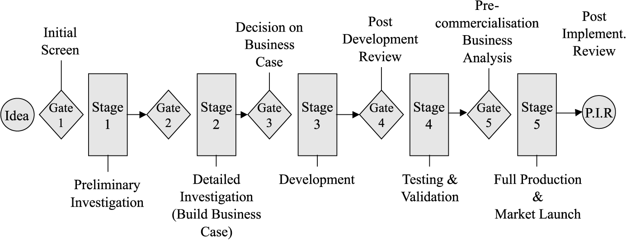
http://www.emeraldinsight.com/journals.htm?articleid=1463188&show=html

A common Stage-Gate Process Model contains the following stages:
- Discovery (Stage 0)
- Preliminary Investigation (Stage 1)
- Build Business Case (Stage 2)
- Development (Stage 3)
- Testing & Validation (Stage 4)
- Full Production & Market Launch (Stage 5)

Discovery (Stage 0)
The discovery stage is the first portion of any product development whether or not the stage gate process is being used. During this basic stage, the development team is deciding what projects the company or school wants and is capable to pursue. Once the team has selected a project that they would like to go forward with, it must be proceed on to the first gate and then screened by the administration’s decision makers.
Preliminary Investigation (Stage 1)
The second stage of the product development process is preliminary investigation. During this step the main goal is to evaluate the product and its market. The researchers must recognize the strengths and weaknesses of the product and what it is going to offer to the potential consumer. Also, it is important for the researchers to understand who and what is already in the market as well as what can possibly be developed. By determining the competition, the management team will be able to decide whether or not they should move forward with the manufacture of the product or if they should permit the product to go onto the next stage.

Build Business Case (Stage 2)
Once the new product passes through gate one after the preliminary investigation stage, it moves to building the business case and plan. This stage is the last stage of concept development where it is important to perform a solid analysis before they begin creating the invention. This phase is usually challenging, complex, and resource-intensive compared to the other stages in the model. Companies must put forth a lot of effort in this stage because it is directly associated to the success and growth of a new product. There are four main steps that comprise this stage: Product Definition and Analysis, Building the Business Case, Building the Project Plan, and Feasibility Review.
Product Definition and Analysis
Product Definition and Analysis, is composed of an arrangement of actions that will give you the information to define and defend the development of a new product. First, what creates value for the costumer needs to be determined. This acknowledges questions about the product such as what s do the product offers and what features the product should have. Next, a market analysis should be formed, where the market size and separation, rate of growth, buyer trend and behavior, and what channels to reach these buyers is determined. A competitive analysis must then be performed; this is where you learn the competitor’s strength and weaknesses. These will help define the product and creates groundwork for the marketing strategy. Next, a technically feasible product idea must be developed. This includes the material and procedures needed to produce the new product. Once this is accomplished, the company can then produce a production and operations cost analysis as well as a launch and market costs analysis. The company can then begin to test the idea they have established. This is when examples are recognized then presented to gain feedback. From this, necessary changes can be made. Lastly, a business analysis, risk analysis, and financial analysis of the new product will be conducted.
Building the Business Case
The second step is building the business case. The business case defines what the product is and the foundation to develop it. The documents may vary depending on the product and company but most have results of the activities of Product Definition and Analysis, supervisory and legal requirements, health, safety, and environmental concerns. Also, assumptions that are made to draw the conclusion that you have thus far and why you believe it is reasonable. This is a document that will be referred to throughout the process and it can be changed at any time.
Building the Project Plan
The next step is building the project plan. This includes creating a schedule of duties and events, as well as timelines to follow throughout the process. The project plan also provides an expected launch date for the product.
Practicability Review
This is the last step for building a business case. This is when information from the three previous steps is analyzed and decided if it should continue through the Stage-Gate Process.
Product Development (Stage 3)
The product development stage is when plans from the previous stages are performed. The products design and development is carried out and it begins to be tested. The marketing and production plans for the product are also carried out during this stage. The development team maps out a realistic timeline with specific goals that are describe as SMART: Specific, Measurable, Actionable, Realistic, and Time bound. The timeline that was created is frequently reviewed and modernized. This helps the team to stay on track, while also giving updates on the products progress. The product developmental stage is when the company makes used of teamwork; the marketing, manufacturing, technical, and sales departments all come together.
Testing and Validation (Stage 4)
This stage has a purpose of providing validation for the project. There will be many areas of the project that will be viewed during this stage such as the product as a whole, the process it takes to manufacture the product, how customers accept the product, and how the project will provide financial gain. There is three testing phases that help validate the product during this stage and they are Near Testing, Field Testing, and Marketing Testing.
Near Testing
Near testing is vital in order to find any problems with the product. Testing is usually done by partners, staff, and close customers to the firm. Members of the research team will also be there to observe the testing.
Field Testing
Field testing is done when there are people who provide feedback on the product. At this testing phase the product will match the planned launch in every way possible. The first objective that is observed is how much the participant is interested in the product. The second objective that is observed is how the participant is planning on using the product. The last feedback is recording and analyzing the feedback that was received from the participants. This feedback will help with minor alterations that need to be made to the product.
Market Testing
Market testing is the last phase in the Testing and Validation stage of the process. This stage is optional depending on the results from the other two tests. The objective of this stage is to predict sales and to make changes that might need to be made to the product.
Product Launch (Stage 5)
The last stage of the Stage-Gate Process is Product Launch. This stage is the most important stage because it is the stage where the culmination of the product needs to meet proper requirements. The company must come up with a marketing plan to produce a demand for the product. Also, the company needs to determine how high of a demand the product will be so they can determine the starting product volume production. Having a straight forward launch process is important because it creates a faster time to profit, more effective marketing, prepared and well-informed sales, and hopefully early acceptance from costumers. Companies must also select a distributor of their product which must be done carefully because potential sales are at risk. All of these factors will lead to a smooth launch and successful product.
Gates
A common Stage-Gate Process also has gates after every stage. The gates check whether the prior step is completed in a quality manner, if the project looks like a worthy idea from a business standpoint, and if the suggested action plan is rational. The gates also decide to advance the product onto the next stage, to send it back to the beginning, or to send the product back to the inventor.

  - Moving an AMP Center case study through the Stage-Gate Process
A certain technology/product was given, from the AMP Center, to analyze and process through the original Stage-Gate Process. The process the technology/product went through is not able to be explained due to disclosure rights.
- Results
The original Stage-Gate Process that was designed for the South Dakota School of Mines & Technology was designed with intentions to have the minimum amount of time or investment before it was found that there was no patentable outcome. It was also designed to be stacked by rank. It was stacked like this because if the project did have to be thrown out there was not a huge amount of investment time put in. The suggestion for this method was that there was a breakdown of searches that were the same for the sake of resource optimization. In this method, the resources were managed as effective as they possibly could be; this is a great strength of the process. The resources are also given the financial situation of the school and country. The effectiveness is a respected objective. The equilibrium of the usefulness and competence was evaluated when the process executed with a group of students who are undergraduates and graduates, and faculty.
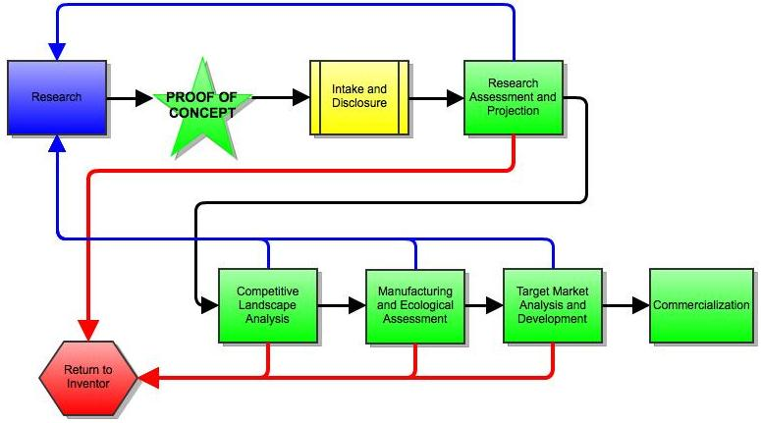
From the case study, it was found that it is difficult to look at only one specific segment. For example, it is difficult to continue performing a patent screening and not look into questioning sections that were not synchronized or following the patent screening. Also, when the process was presented to researchers and faculty, it was shown that a condensed overview was needed. The question of why comparable steps were fragmented in the process came up from the critiquing of the process. It was also seen that needs needed to be expanded to be open to the public because when ideas come from the public there was no research or development done. The stages of the process were accumulated in a more methodical way which is shown below. None of the original stages were taken out or greatly changed, but the stages were reorganized so the process would be easier to explain.
The shift that was made to the new process includes the needs that the stakeholders verbalized. The process also produces a simpler process that is easier to remember, while also being easier for people who are working through the process to move more systematically through the stages.

The SEED process is broke down into the following periods:
- Research
- Proof of Concept
- Intake and Disclosure
- Research Assessment and Projection
- Competitive Landscape Analysis
- Manufacturing and Ecological Assessment
- Target Market Analysis and Development
- Commercialization

With the new process, these steps allow a larger variety of sources and inventors to use the process. They can come from research being done on the South Dakota School of Mines & Technology camps or research that is conducted off campus.
The major difference of this path compared to the original’s idea only process, is that there is a completed proof of concept. Proof of concept can also be known as a prototype before the disclosure. Also, it is important to realize that there is a noteworthy research that can be accomplished without the proof of concept completed because it will start from the idea stage. The proof of concept is so essential because of the effects it carries with the respects to the United States patent system. Also, the impacts it carries with the respect to the Research of Relevance analysis. The proof of concept also clears an enormous hurdle with the respect to the viability of actually translating the idea to an invention.
The implication with respect to the patent office is because once an idea has actually been invented, there are documentations that need to be addressed immediately. This is important because it will leave a paper trail to authenticate the invention as it can be the difference of a patent granted race, in the United States’ first to invent system. Meaning that, depending on the stage completed, a provisional patent application may be properly filed at the start of the SEED process to get a jump start on competition. An example of this action needed to be concluded rapidly was if an analysis of an invention showed documentation of the invention being produced at a certain time, but a patent application was actually filed by a different corporation three months after the documentation date of the idea. If the South Dakota School of Mines & Technology office would have submitted a provisional patent application at the time of the idea; SDSM&T would have beaten the other company to the filing office.

Furthermore, the capability to analyze the invention as it is produced, allows access to what it will take to actually create and instrument the invention. The completion also has effects as to the manufacturability and environmental analysis, as it is shown in the above diagram. Without the proof of concept completed, the analysis for the environmental impacts, and manufacturing assessment are significantly delayed.
The development of the SEED process creates a valuable and easier process to step AMP technologies through. The upgrade of the process allows for more ideas and products to be put through in a more timely fashion. This can help increase the productivity of AMP products which can then increase the commercialization of the AMP technologies, such as Friction Stir Welding and Cold Spray.
- Conclusion
Summary/Discussion
Even though the original Stage-Gate Process may be the world’s most widely and trusted product innovation process, South Dakota School of Mines & Technology were having issues relating to the original process. The major issue was that there was a need for a more condensed overview and, probably because of the categorical minds of the individuals critiquing the process; the question was also raised as to why similar steps were fragmented in the process flow.
The shift to the new system, SEED, incorporates the needs that were dictated by the investors by producing a simpler process that is easier to recollect and also allows the people who are working on the process to move in a more systematically way from one stage to another.
Future Work
From the research conducted, there can be a continued improvement of the System for Entrepreneurship and Economic, SEED, process. The process can be applied to each individual field available at the South Dakota School of Mines & Technology. Each field could have a slightly different process that pertains to what is needed by the individual field. For example, Chemical Engineers could have a slightly different process then Industrial Engineers.
Also, different case studies can be performed through the same process to see if the same changes that were needed to be done to the original Stage-Gate Process reoccur in different case studies.

References
- Arbegast, W.J. (2006, March). Friction stir welding after a decade of development. Pp. 28-35

- Brandt, B. (n.d.). Group review draft -- a stage-gate process for ip evaluation for south dakota school of mines and technology. Unpublished manuscript, Center for Business and Economics, National American University, Rapid City, South Dakota.

- Cold spray technology from twi. (n.d.). Retrieved from http://www.twi.co.uk/content/twi_yorks_csleaflet.pdf

- Cooper, R.G., Edgett, S.J. (2005). Lean, rapid and profitable new product development;. Canada: Product Development Institute.

- Edgett, S.J., Jones, M.L. (2000-2010). Ten tips for successfully implementing a stage-gate product innovation process. Product Development Institute.

- Mishra, R.S. (2003, October). Friction stir processing technologies, Advanced Materials & Process, pp. 43-46.

- Stage-gate international. (n.d.). Retrieved from http://www.stage-gate.com/

Acknowledgments
The funding for the research came from the National Science Foundation. Advisors Dr. Michael West, Dr. Christian Widener, & Dr. Jennifer Karlin, are greatly appreciated for their assistance throughout the research program. Thanks to Dr. Alfred Boysen for being a guide in writing and speaking. Also, thanks to Peter Franz, Eric East, and Cassandra Groen, South Dakota School of Mines & Technology graduate students, for assisting along the way. Lastly, thanks to the Advanced Material Processing Center for allowing research to be done.

